Thornton Primary School

Social Media Policy

Approved by the Governing Body on 16th July 2019.

Signed ……………………………………………… (Chair of Governors)

To be reviewed in 2021 or earlier if required.
Contents:

Statement of intent

1. Key roles and responsibilities

2. Definitions

3. Training of staff

4. Pupil expectations

5. Social media use - staff

6. Social media use - pupils and parents / carers

7. The school blogging rules

8. Blocked content

9. Cyber bullying

10. Be SMART online

11. Appendices

1. Blocked content access form

2. Social media home school agreement forms

Statement of intent

At Thornton Primary School we understand that social media is a growing part of life outside of school. We have a responsibility to safeguard our pupils against potential dangers when accessing the internet at school, and to educate our pupils about how to protect themselves online when outside of school.

At Thornton we are committed to:

- Encouraging the responsible use of social media in support of the school’s mission, values and objectives.
- Protecting our pupils from the dangers of social media.
- Preventing and avoiding damage to the reputation of the school through irresponsible use of social media.
- Protecting our staff from cyber bullying and potentially career damaging behaviour.
- Arranging e-safety meetings for parents.
1. Key roles and responsibilities

The governing body has overall responsibility for the implementation of the Social Media Policy and procedures of Thornton Primary School

The governing body has responsibility for ensuring that the Social Media Policy, as written, does not discriminate on any grounds, including but not limited to: ethnicity/national origin, culture, religion, gender, disability or sexual orientation.

The governing body has responsibility for handling complaints regarding this policy as outlined in the school’s Complaints Policy.

The Headteacher will be responsible for the day-to-day implementation and management of the Social Media Policy and procedures of Thornton Primary School.

Staff, including teachers, support staff and volunteers, will be responsible for following the Social Media Policy and for ensuring pupils do so also. They will also be responsible for ensuring the policy is implemented fairly and consistently in the classroom.

Parents and carers will be expected to take responsibility for the social media habits of their child/children at home.

Parents and carers will be expected to promote safe social media behaviour.

The school’s e-safety team and network manager

The school’s e-safety team consists of:

S. Simmons, Headteacher

C. Grace, Deputy Headteacher

Mrs J. Dixon-Ricketts, IT/Computing subject leader

M. Sajid, IT Network Manager

2. Definitions

Thornton Primary School defines “social media” as any online platform that offers real-time interaction between the user and other individuals or groups including but not limited to:

- Blogs
- Online discussion forums, such as netmums.com
- Collaborative spaces, such as Facebook, Instagram and Snapchat
- Media sharing services, such as YouTube
- ‘Micro-blogging’ applications, such as Twitter
- Thornton Primary School defines “cyber bullying” as any use of social media or communication technology to bully an individual or group.

- Thornton Primary School defines “members of the school community” as any teacher, member of support staff, pupil, parent/carer of pupil, governor or ex-pupil.

3. Training of staff

At Thornton Primary School we recognise that early intervention can protect pupils who may be at risk of cyber bullying or negative social media behaviour. As such, teachers will receive training in identifying potentially at-risk pupils.

Teachers and support staff will receive training on the Social Media Policy as part of their new starter induction.

Teachers and support staff will receive regular and ongoing training as part of their development.

4. Pupil expectations

Pupils are responsible for following the school rules and will be expected to follow requests from teachers.

5. Social media use - staff

    - School social media passwords are kept by the network manager and any staff member in charge of sharing year group information. The passwords must never be shared.

    - N. Couldrey (Assistant Head) is responsible for the school’s social media accounts.

    - Teachers may not access social media during lesson time, unless it is part of a curriculum activity.

    - Teachers may use social media during their break times.

    - Members of staff are not allowed to use personal social media in front of pupils.

    - Members of staff must not “friend” or “follow” or otherwise contact pupils, current or past, or parents/carers through social media.

    - If pupils or parents/carers attempt to “friend” or otherwise contact members of staff
through social media, they should be reported to the headteacher.

    - Members of staff should avoid identifying themselves as an employee Thornton
Primary School on social media.

    - Members of staff must not post content online which is damaging to the school or any of its staff or pupils.

    - Where teachers or members of staff use social media in a personal capacity, they should make it clear that their views are personal.
    - Teachers or members of staff must not post any information which could identify a pupil, class or the school.

    - Members of staff should not post anonymously or under an alias to evade the guidance given in this policy.

    - Breaches of this policy by members of staff will be taken seriously, and in the event of illegal, defamatory or discriminatory content, could lead to prosecution, disciplinary action or dismissal.

Members of staff should be aware that if their out-of-work activity brings Thornton
    - Primary School into disrepute, disciplinary action will be taken.

    - Members of staff should regularly check their online presence for negative content via search engines.

    - If inappropriate content is accessed online, an inappropriate website content report form should be completed and passed on to the Headteacher.

    - Attempts to bully, coerce or manipulate members of the school community, via social media, by teachers and members of staff will be dealt with as a disciplinary matter.

    - Members of staff should not leave a computer or other device logged in when away from their desk, or save passwords.

    - Staff members should use their school email address for school business and personal email address for their private correspondence; the two should not be mixed. Personal email addresses should never be given out to parents to discuss any aspect of the school’s work, including discussing pupils.

6. Social media use – pupils and parents/carers

    - Pupils may not access social media in school.

    - Breaches of this policy by pupils will be taken seriously, and in the event of illegal, defamatory or discriminatory content could lead to prosecution, or exclusion.

    - Pupils and parents/carers must not attempt to “friend”, “follow” or otherwise contact members of staff through social media. If attempts to contact members of staff through social media are made, they will be reported to the Headteacher.

    - If members of staff attempt to “friend”, “follow” or otherwise contact pupils or parents/carers through social media, they should be reported to the Headteacher.

    - Pupils and parents/carers should not post anonymously or under an alias to evade the guidance given in this policy.
    - Pupils and parents/carers must not post content online which is damaging to the school or any of its staff or pupils.

    - Pupils at Thornton Primary School must not sign up to social media sites that have
an age restriction above the pupil’s age.

    - If inappropriate content is accessed online on school premises, it must be reported to a teacher.

7. Rules for blogging

A blog can be very exciting, it allows people from all over the world to share our learning and make comments. We need to remember to follow a few simple rules to stay safe and to get the most out of our blog. It is very important that we understand how to use the blog and the internet in a secure way. This ties in with National Curriculum objectives and Computing Key Skills that the children are expected to learn and apply.

The following guidelines have been established to ensure the safety of our pupils when blogging. The guidelines are also reminders of how to use the blog to improve writing and keyboarding skills.

Pupils should follow our blogging rules:

- Only use your first name when commenting – no surnames.
- Keep safe – don’t reveal any personal information.
- No text talk – write in full sentences and read your comments back carefully before submitting.
- Be polite – don’t post anything that could hurt anyone.
- Always show respect – be positive if you are going comment and always remember that the blog is an extension of our school that the rest of the world is able to see.
- All posts and comments are checked by school staff before they are approved.

8. Blocked content

The following social media websites are blocked by the network’s firewalls:

- Facebook
- Snapchat
- Instagram

Attempts to circumvent the network’s firewalls will result in a ban from using school computing equipment, other than with close supervision.

Inappropriate content which is accessed on the school computers should be reported to Mohammed Sajid so that the site can be blocked.

Requests may be made to access erroneously blocked content by submitting a
“blocked content access” form (Appendix 1) to the Headteacher.
The final decision on whether access should be granted to a site will be made by the
Headteacher.

9. Cyber bullying

At Thornton Primary School, cyber bullying is taken seriously. Incidents of cyber bullying will be dealt with and reported along the same chain as the Anti-Bullying Policy.

Staff members should never respond or retaliate to cyberbullying incidents. Incidents should instead be reported as inappropriate, and support sought from their line manager or senior staff member. Evidence from the incident should be saved, including screen prints of messages or web pages, and the time and date of the incident.

Where the perpetrator is a current pupil or colleague, most cases can be dealt with through the school’s own disciplinary procedures.

Where the perpetrator is an adult, in nearly all cases, a senior staff member should invite the victim to a meeting to address their concerns. Where appropriate, the perpetrator will be asked to remove the offensive content.

If the perpetrator refuses to comply, it is up to the school to decide what to do next.
This could include contacting the internet service provider in question through their reporting mechanisms, if the offensive content breaches their terms and conditions.

If the material is threatening, abusive, sexist, of a sexual nature or constitutes a hate crime, the school should consider contacting the police.

As part of our on-going commitment to the prevention of cyber bullying, regular education and discussion about e-safety will take place as part of computing and PSHE.

10. Be SMART online

We encourage pupils to take a SMART approach to social media behaviour:

Safe Do not give out personal information, or post photos of yourself to people you talk to online. Follow age restriction rules.
Meeting Do not meet somebody you have only met online. We encourage
parents/carers to speak regularly to their children about who they are talking to online.
Accepting We advise that pupils only open emails and other forms of
communication from people they already know.
Reliable We teach pupils about the dangers of believing everything they see online.
Tell We encourage pupils to tell a teacher, parent or carer if they see anything online that makes them feel uncomfortable.

Appendix 1 – Blocked content access form

Blocked website content access request form
Teacher name:

Full URL:

Site content:

Reasons:

Risks:

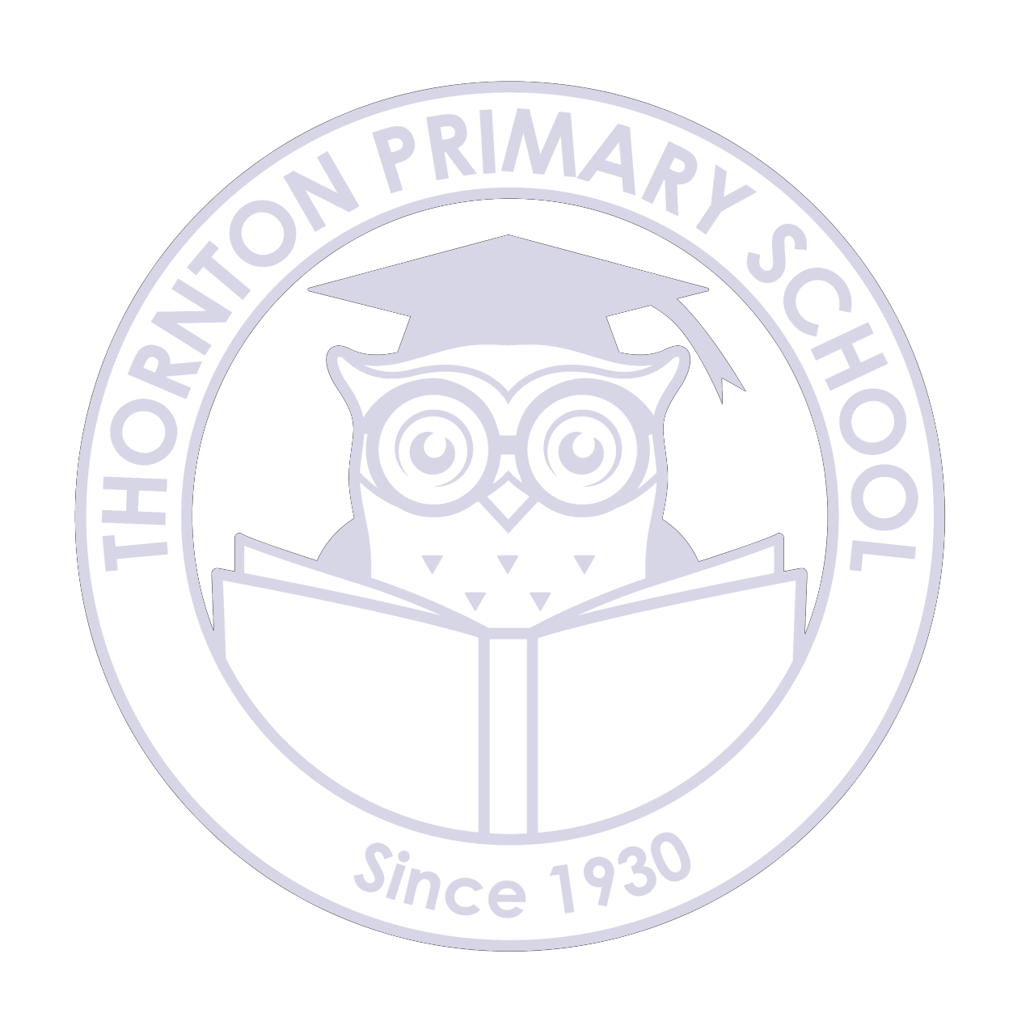Approved
Yes
No
Reason:
Appendix 2 - Contact details for social networking sites

Social networking site | Useful links
Ask. Fm | Terms of service  Safety tips
BBM | Rules and safety
Facebook | Rules  Report to Facebook  Safety Centre
Instagram | Rules  Report to Instagram  Safety Centre
Kik Messenger | Rules  Report to Kik  Help Centre
Snapchat | Rules  Report to Snapchat  Safety tips for parents
Tumblr | Rules  Report to Tumblr  If you email Tumblr, take a screenshot as evidence and attach it.
Twitter | Rules  Report to Twitter
Vine | Rules  Contacting Vine and reporting
YouTube | Rules  Report to YouTube  Safety Centre

